# **Chapter 7**

## What are pseudo-ops

**Directives or psuedo-ops give information to the**

**assembler.**

**• Not executed by the program**

**• All directives start with a period “.‟**

### **Directive Description**

**.ORIG**

Where to start in placing things in memory

**.FILL**

Declare a memory location (variable)

**.BLKW**

Declare a group of memory locations (array)

**.STRINGZ**

Declare a group of characters in memory (string)

**.END**

Tells assembly where your program source ends

## **Two Passes in the Assembler**

### **First Pass**

* **scan program file**

**- Find all labels and calculate the corresponding addresses - the symbol table**

**Find the .ORIG statement,**

**which tells us the address of the first instruction.**

**• Initialize Location Counter (LC), which keeps track of the**

**current instruction.**

**2. For each non-empty line in the program:**

**a) If line contains a label, add label and LC to symbol table.**

**b) Increment LC.**

**– NOTE: If statement is .BLKW or .STRINGZ,**

**increment LC by the number of words allocated.**

**3. Stop when .END statement is reached.**

**NOTE: A line with only a comment is considered an empty line.**

### **Second Pass**

* **Convert instructions to machine language, using information from symbol table**

**For each executable assembly language statement,**

**generate the corresponding machine language instruction.**

**– If operand is a label,**

**look up the address from the symbol table.**

**• Potential problems:**

**– Improper number or type of arguments**

**• ex: NOT R1,#7**

**ADD R1,R2**

**– Immediate argument too large**

**• ex: ADD R1,R2,#1023**

**– Address (associated with label) more than 256 from instruction**

**• can‟t use PC-relative addressing mode**

## **Symbol table**

In symbol table we keep the track of every statement   
i.e after .orig 0x300 we know whether the

Opcode is valid or not. But if there is some label than that

Label is also added to the Symbol table and and LC is incremented.

## **Symbol table for Simple Multiply Program**

|  |  |  |  |  |
| --- | --- | --- | --- | --- |
| **Hex Address** | **Label / Instruction** | **Destination** | **Source1(Reg)** | **Source2(Reg)** |
|  | **.ORIG x3000** |  |  |  |
| **x3000** | **LD** | **R2** | **zero** |  |
| **X3001** | **LD** | **R0** | **M0** |  |
| **X3001** | **LD** | **R1** | **M1** |  |
| **X3001** | **Loop BrZ Done** |  |  |  |
| **X3001** | **Add** | **R2** | **R2** | **R0** |
| **X3001** | **Add** | **R1** | **R1** | **#-1** |
| **X3001** | **Br Loop** |  |  |  |
| **X3001** | **Done St** | **R2** | **Result** |  |
| **X3001** | **Halt** |  |  |  |
| **X3001** | **Result .Fill 0x000** |  |  |  |
| **X3001** | **Zero .Fill 0x000** |  |  |  |
| **X3001** | **M0 .Fill 0x007** |  |  |  |
| **X3001** | **M1 .Fill 0x003** |  |  |  |
|  | **.END** |  |  |  |

## **LD, LDR, LEA, LDI**

**LEA R0, A -- R0 has the address of A**

**LDI R2, C -- R2 has value of which address C has**

**LDR R3, R0, 2 -- R3 has the value of C**

**-- Because R0 has the address of A + 2 positions = C**

# **CHAPTER 9**

## **Subroutines**

**Blocks can be encoded as subroutines**

**A subroutine is a program fragment that:**

**– lives in user space**

**– performs a well-defined task**

**– is invoked (called) by a user program**

**– returns control to the calling program when finished**

## **Parameters, Arguments and Returned Values**

## **Arguments**

## **– A value passed in to a subroutine (or trap) is called an argument.**

## **– This is a value needed by the subroutine to do its job.**

## **– Examples:**

## **• In 2sComp routine, R0 is the number to be negated**

## **• In PUTS routine, R0 is address of string to be printed.**

## **Return Values**

## **– A value passed out of a subroutine is called a return value.**

## **– This is the value that you called the subroutine to compute.**

## **– Examples:**

## **• In 2sComp routine, negated value is returned in R0.**

## **• In GETC service routine, character read from the keyboard**

## **is returned in R0.**

## **Call by Reference and Call by Value**

Call By reference means to pass the address of the variable to the function and than the function alters the value stored in that address.

Call by Value means to pass the value of the variable to the function and function process that value and returns the result.

## **Calling a Subroutine in LC3**

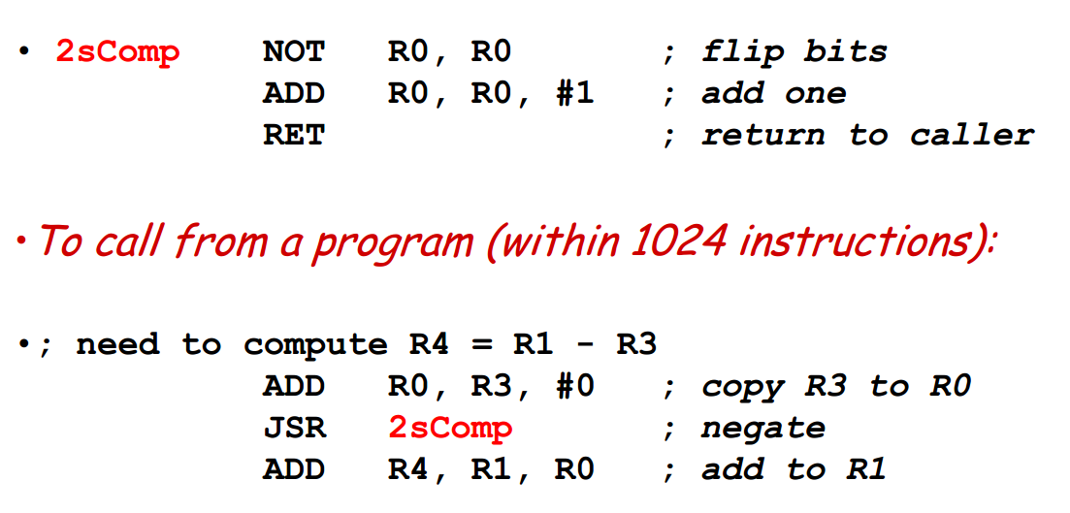

## **JSR**

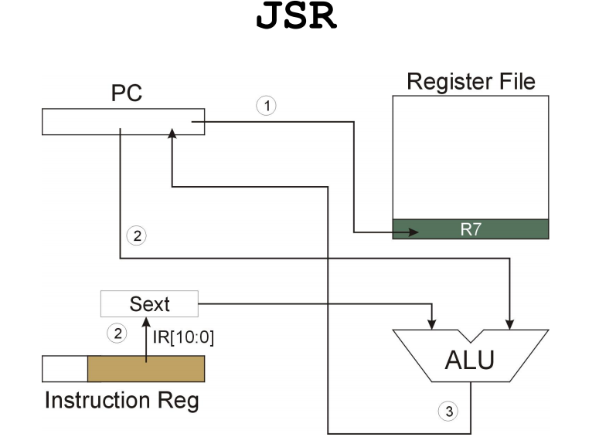

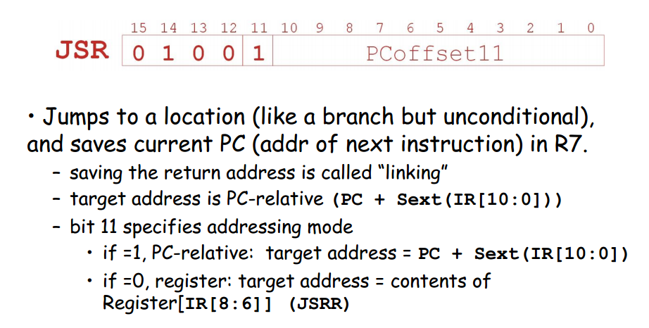

## **JSRR**

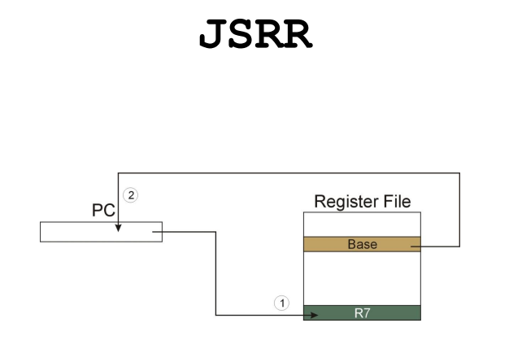

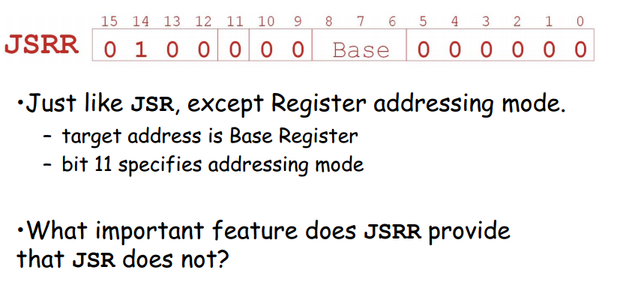

## **Saving Without Stack**

In order to save without stack we will make an array in which we dump our all registers values as well as we can pass values to the functions through it .

## **Trap**

**TRAP instruction**

* **Used by program to transfer control to operating system**
* **8-bit trap vector names one of the 256 service routines**

